Ex. No. 10 | EMAIL AUTOMATION IN UI PATH
Date of Exercise | 16/04/2026

AIM
To automate the process of sending emails using UiPath Studio.
DESCRIPTION
This experiment demonstrates how to automate the process of sending emails using UiPath Studio. In this workflow, the automation begins by connecting to a Gmail account using the Use Gmail activity, which allows secure access for sending emails. The bot then uses the Send Email activity to compose and send messages by specifying the receiver’s email address, subject, and body content. Additional settings, such as disabling the “Save as Draft” option, ensure that the email is sent directly without manual intervention. This automation eliminates the need for repetitive manual emailing tasks, making communication faster and more efficient. Overall, the experiment highlights how UiPath can streamline email operations, improve productivity, and ensure reliable message delivery in real-time scenarios.
PROCEDURE:
Step 1: Open UiPath studio and click process to start a new project.
Step 2: Create a new blank process by giving a name and give create.
Step 3: Click Open main workflow.
Step 4: You will get the main workflow.
Step 5: To automate the process of sending emails using UiPath Studio.
Step 6: Click on please select an account and then click ok button.
Step 7: Add or select a google account for sending the Email.
Step 8: From activities chose send email option from it.
Step 9: Add the receiver email address in double quotes and type subject and body in it.
Step 10: Go to properties and deselect the save as draft option in it.

OUTPUT:
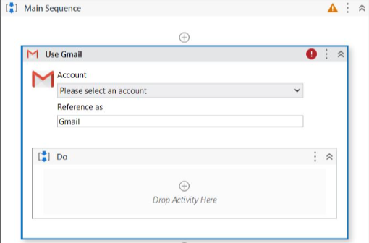

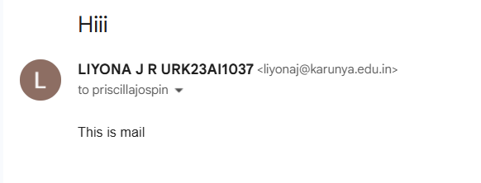

Result:
Thus, the email automation is done using UiPath Studio.

